**JAVA PROGRAMMING EXERCISE - MAY 13th**

**Question 1:**

**Code:**

import java.util.*\**;

public class qs1 {

public static void main(String[] args) {

Scanner sc = *new* Scanner(System.in);

Scanner sc1 = *new* Scanner(System.in);

*try* {

System.out.print("Enter name: ");

String name = sc.nextLine();

System.out.print("Enter first number: ");

int num1 = sc1.nextInt();

System.out.print("Enter second number: ");

int num2 = sc1.nextInt();

calculator c = *new* calculator(name, num1, num2);

c.add();

c.divide();

c.display_namelength();

} *catch* (InputMismatchException e) {

System.out.println("Please enter correct type for Name and Number");

} *catch* (ArithmeticException e) {

System.out.println("Cannot divide number by zero");

} *catch* (Exception e) {

System.out.println(e.getMessage());

} *finally* {

sc.close();

sc1.close();

}

}

}

class calculator {

String name;

int num1;

int num2;

public calculator(String name, int num1, int num2) {

*this*.name = name;

*this*.num1 = num1;

*this*.num2 = num2;

}

public void add() {

System.out.println(num1 + num2);

}

public void divide() {

System.out.println(num1 / num2);

}

public void display_namelength() {

System.out.println(name.length());

}

}

**Output:**

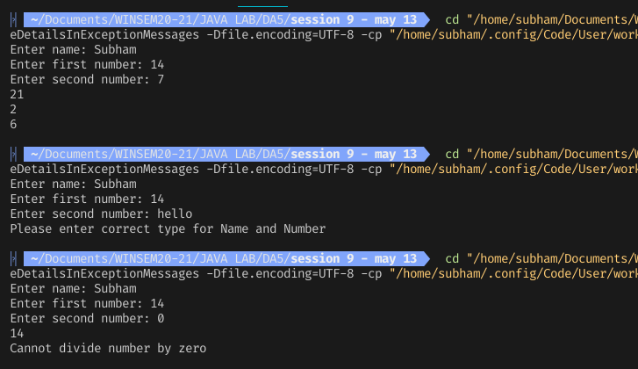

**Question 2 - a:**

**Code:**

import java.io.*\**;

public class qs2a {

public static void main(String[] args) throws IOException {

int sum1 = operationFile1();

int sum2 = operationFile2();

int sum3 = operationFile3();

int sum4 = operationFile4();

System.out.println("The sum of all numbers from all files is "+(sum1+sum2+sum3+sum4));

}

public static int operationFile1() throws IOException {

FileInputStream fstream = *new* FileInputStream("file1.txt");

DataInputStream in = *new* DataInputStream(fstream);

BufferedReader br = *new* BufferedReader(*new* InputStreamReader(in));

String data;

int sumMain = 0, sumFile = 0;

*while* ((data = br.readLine()) != null) {

String[] tmp = data.split(" ");

*for* (String s *:* tmp) {

sumMain += Integer.parseInt(s);

*if* (s.contains("9") || s.contains("7")) {

sumFile += Integer.parseInt(s);

}

}

}

System.out.println("From file 1: Sum of numbers that contain 7 or 9 is " + sumFile);

br.close();

*return* sumMain;

}

public static int operationFile2() throws IOException {

FileInputStream fstream = *new* FileInputStream("file2.txt");

DataInputStream in = *new* DataInputStream(fstream);

BufferedReader br = *new* BufferedReader(*new* InputStreamReader(in));

String data;

int sumMain = 0, sumFile = 0;

*while* ((data = br.readLine()) != null) {

String[] tmp = data.split(" ");

*for* (String s *:* tmp) {

sumMain += Integer.parseInt(s);

*if* (Integer.parseInt(s) % 9 == 0 || Integer.parseInt(s) % 11 == 0) {

sumFile += Integer.parseInt(s);

}

}

}

System.out.println("From file 2: Sum of numbers that is divisible by 9 or 11 is " + sumFile);

br.close();

*return* sumMain;

}

public static int operationFile3() throws IOException {

FileInputStream fstream = *new* FileInputStream("file3.txt");

DataInputStream in = *new* DataInputStream(fstream);

BufferedReader br = *new* BufferedReader(*new* InputStreamReader(in));

String data;

int sumMain = 0, sumFile = 0;

*while* ((data = br.readLine()) != null) {

String[] tmp = data.split(" ");

*for* (String s *:* tmp) {

sumMain += Integer.parseInt(s);

*if* (s.length() == 4 || s.endsWith("8")) {

sumFile += Integer.parseInt(s);

}

}

}

System.out.println("From file 3: Sum of numbers that are 4 digits long and end with 8 is " + sumFile);

br.close();

*return* sumMain;

}

public static int operationFile4() throws IOException {

FileInputStream fstream = *new* FileInputStream("file4.txt");

DataInputStream in = *new* DataInputStream(fstream);

BufferedReader br = *new* BufferedReader(*new* InputStreamReader(in));

String data;

int sumMain = 0;

*while* ((data = br.readLine()) != null) {

String[] tmp = data.split(" ");

*for* (String s *:* tmp) {

sumMain += Integer.parseInt(s);

}

}

br.close();

*return* sumMain;

}

}

**file1.txt:**

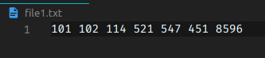

**file2.txt:**

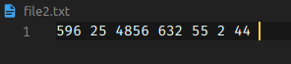

**file3.txt:**

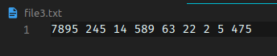

**file4.txt:**

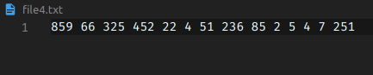

**Output:**

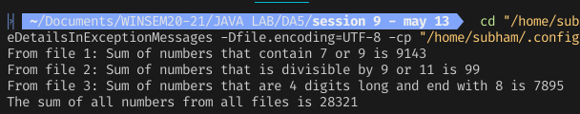

**Question 2-b:**

**Code:**

import java.util.*\**;

public class qs2b {

public static void main(String[] args) {

LinkedList<car> cll = *new* LinkedList<>();

Scanner sc = *new* Scanner(System.in);

*for* (int i = 1; i <= 4; i++) {

System.out.println("----ENTER DETAILS FOR CAR " + i + " ----");

System.out.print("Enter ID: ");

String car_id = sc.nextLine();

System.out.print("Enter Name: ");

String car_name = sc.nextLine();

System.out.print("Enter Brand: ");

String car_brand = sc.nextLine();

cll.add(*new* car(car_id, car_name, car_brand));

System.out.println();

}

System.out.println();

ListIterator<car> itr = cll.listIterator();

*while* (itr.hasNext()) {

car c = itr.next();

*if* (c.car_brand.compareToIgnoreCase("ford")==0) {

c.displayInfo();

}

}

sc.close();

}

}

class car {

String car_id;

String car_name;

String car_brand;

car(String car_id, String car_name, String car_brand) {

*this*.car_id = car_id;

*this*.car_name = car_name;

*this*.car_brand = car_brand;

}

public void displayInfo() {

System.out.println("Car ID: " + car_id + ", Car Name: " + car_name + ", Car Brand: " + car_brand);

}

}

**Output:**

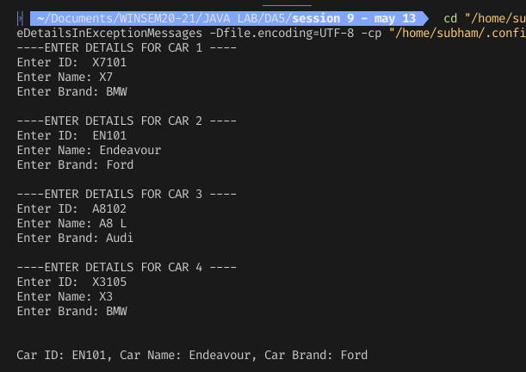

**Question 3:**

**Code:**

import java.io.*\**;

import java.util.*\**;

public class qs3 {

public static void main(String[] args) throws InterruptedException {

FileOperation foper = *new* FileOperation();

Thread thr1 = *new* Thread((Runnable) () -> {

foper.writeObjects();

});

Thread thr2 = *new* Thread((Runnable) () -> {

*try* {

foper.readObjects();

} *catch* (InterruptedException e) {

e.printStackTrace();

} *catch* (FileNotFoundException e) {

e.printStackTrace();

}

});

thr1.start();

thr2.start();

thr1.join();

thr2.join();

}

}

class faculty implements Serializable {

String id;

String designation;

String name;

String gender;

faculty(String id, String designation, String name, String gender) {

*this*.id = id;

*this*.designation = designation;

*this*.name = name;

*this*.gender = gender;

}

faculty() {

*this*.id = "";

*this*.name = "";

*this*.designation = "";

*this*.gender = "";

}

public void displayInfo() {

System.out.println(

"Faculty id: " + id + ", Name: " + name + ", Designation: " + designation + ", Gender: " + gender);

}

public static void sortAndDisplayFacultyByNames(faculty[] farr) {

*for* (int i = 0; i < farr.length - 1; i++) {

*for* (int j = 0; j < farr.length - i - 1; j++) {

*if* (farr[j].name.compareTo(farr[j + 1].name) > 0) {

faculty temp = *new* faculty();

temp = farr[j];

farr[j] = farr[j + 1];

farr[j + 1] = temp;

}

}

}

System.out.println("THE SORTED LIST OF NAMES IS");

*for* (faculty f *:* farr) {

System.out.println(f.name);

}

}

}

class FileOperation {

private boolean fileBusy = false;

public synchronized void writeObjects() {

*try* {

*this*.fileBusy = true;

Scanner sc = *new* Scanner(System.in);

faculty farr[] = *new* faculty[5];

File obj = *new* File("faculty.txt");

FileOutputStream fout = *new* FileOutputStream(obj);

ObjectOutputStream objout = *new* ObjectOutputStream(fout);

*for* (int i = 0; i < 5; i++) {

System.out.println("-----ENTER DEATILS FOR FACULTY " + (i + 1) + " -----");

System.out.print("Enter id: ");

String id = sc.nextLine();

System.out.print("Enter name: ");

String name = sc.nextLine();

System.out.print("Enter designation: ");

String designation = sc.nextLine();

System.out.print("Enter gender(Male/Female): ");

String gender = sc.nextLine();

farr[i] = *new* faculty(id, designation, name, gender);

objout.writeObject(farr[i]);

}

*this*.fileBusy = false;

notifyAll();

objout.close();

sc.close();

} *catch* (InputMismatchException e) {

System.out.println("Please enter the objin of correct type");

} *catch* (Exception e) {

System.out.println(e.getStackTrace());

}

}

public synchronized void readObjects() throws InterruptedException, FileNotFoundException {

faculty farr[] = *new* faculty[5];

System.out.println("WAITING TO READ FILE faculty.txt");

*while* (fileBusy)

wait();

*try* {

System.out.println("FINISHED WAITING TO READ FILE faculty.txt");

FileInputStream fis = *new* FileInputStream("faculty.txt");

*try* (ObjectInputStream input = *new* ObjectInputStream(fis)) {

*for* (int i = 0; i < 5; i++) {

faculty f = (faculty) input.readObject();

farr[i] = f;

*if* (f.designation.compareTo("Assistant Professor") == 0) {

f.displayInfo();

}

}

} *catch* (Exception e) {

e.printStackTrace();

}

faculty.sortAndDisplayFacultyByNames(farr);

} *catch* (Exception e) {

e.printStackTrace();

}

}

}

**Output:**

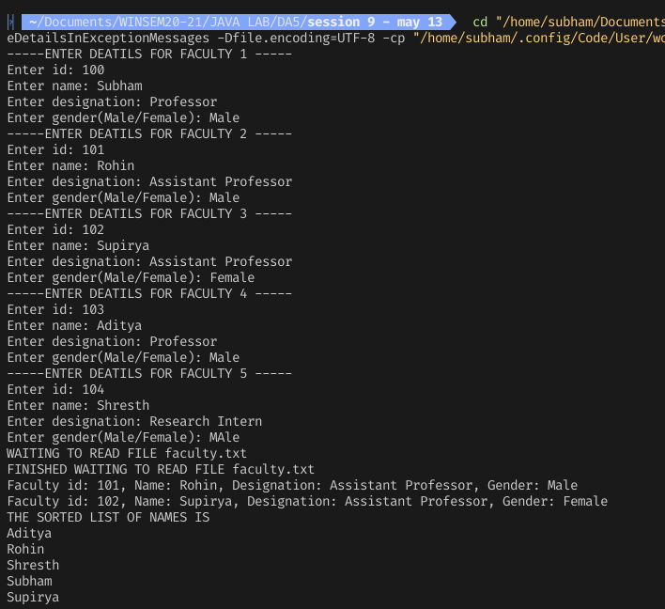

**Question 4:**

**Code:**

import java.io.*\**;

import java.util.Scanner;

public class qs4 {

public static void main(String[] args) throws InterruptedException {

fileOperation fo = *new* fileOperation();

Thread thr_read1 = *new* Thread((Runnable)() -> {

*try* {

fo.readAndAdd();

} *catch* (Throwable e) {

e.printStackTrace();

}

});

Thread thr_read2 = *new* Thread((Runnable)() -> {

*try* {

fo.readAndMultiply();

} *catch* (Throwable e) {

e.printStackTrace();

}

});

Thread thr_write = *new* Thread((Runnable)() -> {

*try* {

fo.writeToFile();

} *catch* (Throwable e) {

e.printStackTrace();

}

});

thr_read1.start();

thr_read2.start();

thr_write.start();

thr_read1.join();

thr_read2.join();

thr_write.join();

}

}

class fileOperation {

private boolean fileBusy = false;

public synchronized void writeToFile() throws Throwable {

fileBusy = true;

Scanner sc = *new* Scanner(System.in);

FileOutputStream fout = *new* FileOutputStream("input.txt");

DataOutputStream dout = *new* DataOutputStream(fout);

System.out.println("Enter first number: ");

int num1 = sc.nextInt();

System.out.println("Enter second number: ");

int num2 = sc.nextInt();

dout.writeInt(num1);

dout.writeInt(num2);

System.out.println("THE TWO NUMBERS HAVE BEEN WRITTEN TO FILE input.txt");

dout.close();

sc.close();

fileBusy = false;

notifyAll();

}

public synchronized void readAndAdd() throws Throwable {

FileInputStream fin = *new* FileInputStream("input.txt");

DataInputStream din = *new* DataInputStream(fin);

*while* (fileBusy || din.available()==0) {

System.out.println("THREAD READ 1 IS WAITING");

wait();

}

int num1 = din.readInt();

int num2 = din.readInt();

System.out.println("Sum: " + (num1 + num2));

din.close();

}

public synchronized void readAndMultiply() throws Throwable {

FileInputStream fin = *new* FileInputStream("input.txt");

DataInputStream din = *new* DataInputStream(fin);

*while* (fileBusy || din.available()==0) {

System.out.println("THREAD READ 2 IS WAITING");

wait();

}

int num1 = din.readInt();

int num2 = din.readInt();

System.out.println("Sum: " + (num1 * num2));

din.close();

}

}

Output:

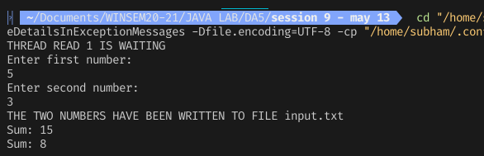

**tQuestion 5:**

**Code:**

import java.util.*\**;

public class qs5 {

public static void main(String[] args) {

LinkedList<Customer> cl = *new* LinkedList<Customer>();

Scanner sc = *new* Scanner(System.in);

*for* (int i = 0; i < 5; i++) {

System.out.println("-----CUSTOMER " + (i + 1) + " -----");

System.out.print("Enter name: ");

String name = sc.next();

System.out.print("Enter purchase amount: ");

double p = sc.nextDouble();

cl.add(*new* Customer(name, p));

}

Iterator<Customer> iterator = cl.descendingIterator();

int count = 0;

*while* (iterator.hasNext()) {

Customer itr = iterator.next();

System.out.println("Nmae of Customer "+(count++)+": "+itr.name+", Amount of purchase: "+itr.purchase);

}

sc.close();

}

}

class Customer {

String name;

double purchase;

public Customer(String name, double amount) {

*this*.name = name;

*this*.purchase = amount;

}

}

**Output:**

